Jenkins-01
- Install Jenkins and run Jenkins on port number 8081.
  - Launch Instance
Go to AWS Console → EC2 Click Launch Instance
Select: AMI → Instance type → t2.microKey pair
Security Group → Allow:
SSH (22) and Custom TCP → 8081
Click on launch instance
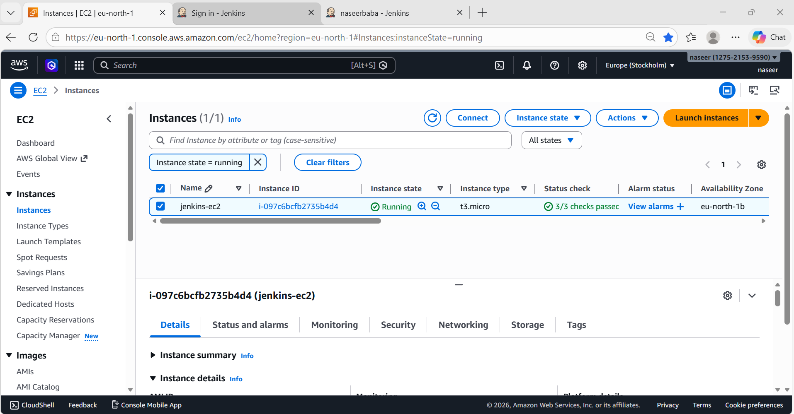
Connect to EC2
ssh -i your-key.pem ec2-user@<public-ip>
Jenkins requires Java
sudo yum update -y
sudo yum install java-17-amazon-corretto -y
Install Jenkins
sudo wget -O /etc/yum.repos.d/jenkins.repo \
https://pkg.jenkins.io/redhat-stable/jenkins.repo
sudo rpm --import https://pkg.jenkins.io/redhat-stable/jenkins.io.key
sudo yum install jenkins -y
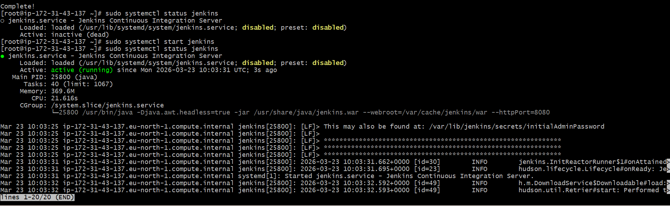

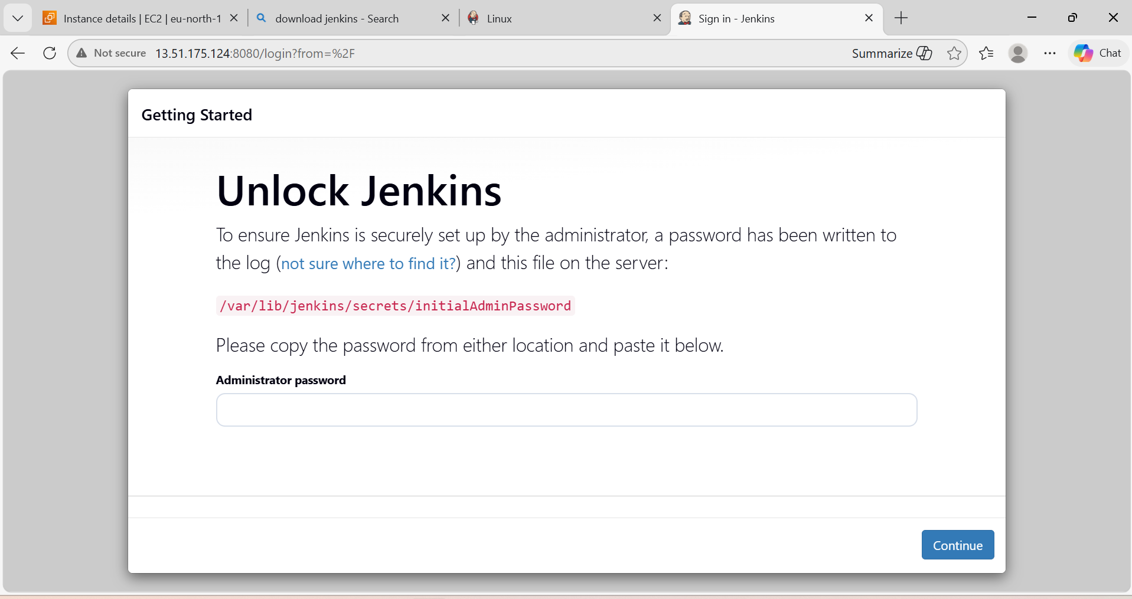
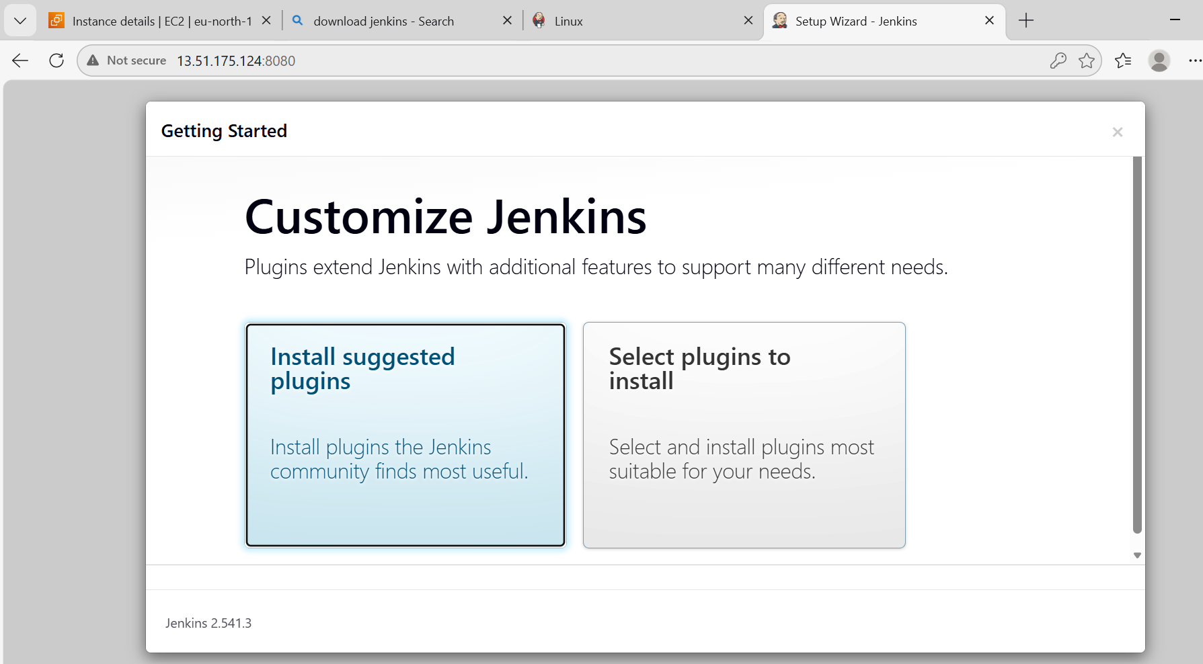

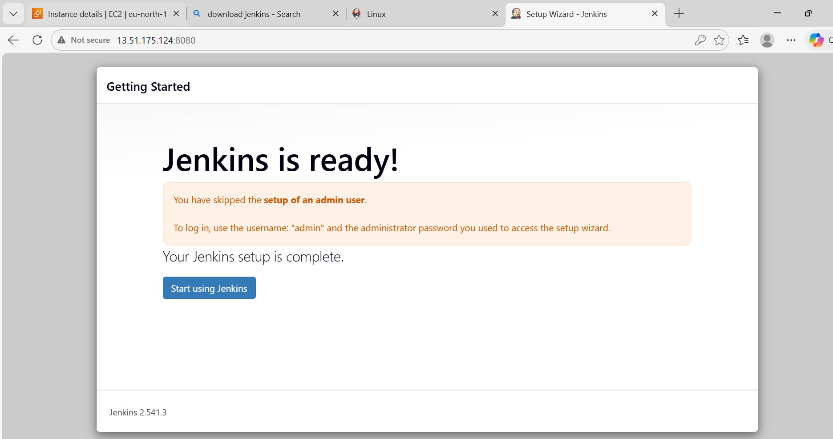
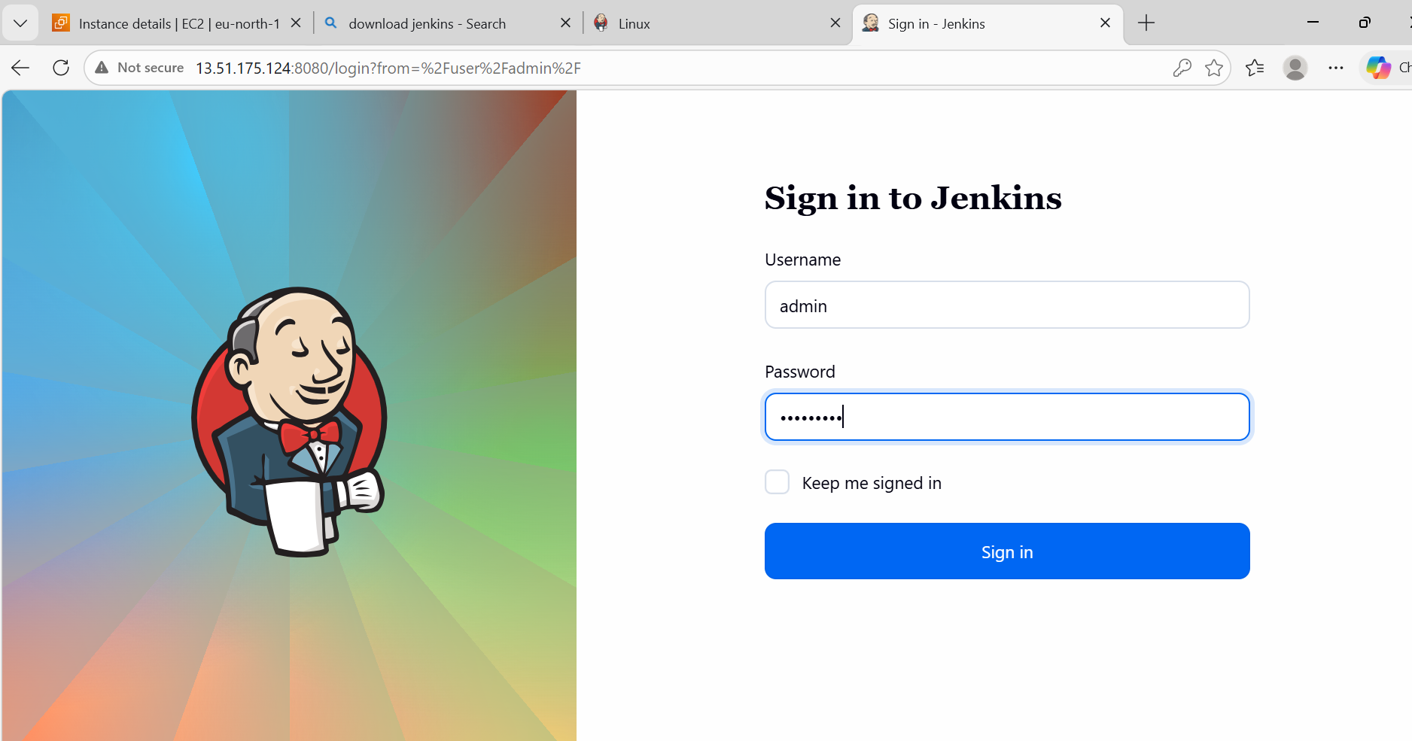
Change Port (8080 → 8081)
Important for your question
sudo vi /usr/lib/systemd/system/jenkins.service
Change:
JENKINS_PORT="8081"
sudo systemctl start jenkins
sudo systemctl enable Jenkins
sudo systemctl status Jenkins
Open Jenkins in Browser
http://<EC2-PUBLIC-IP>:8081

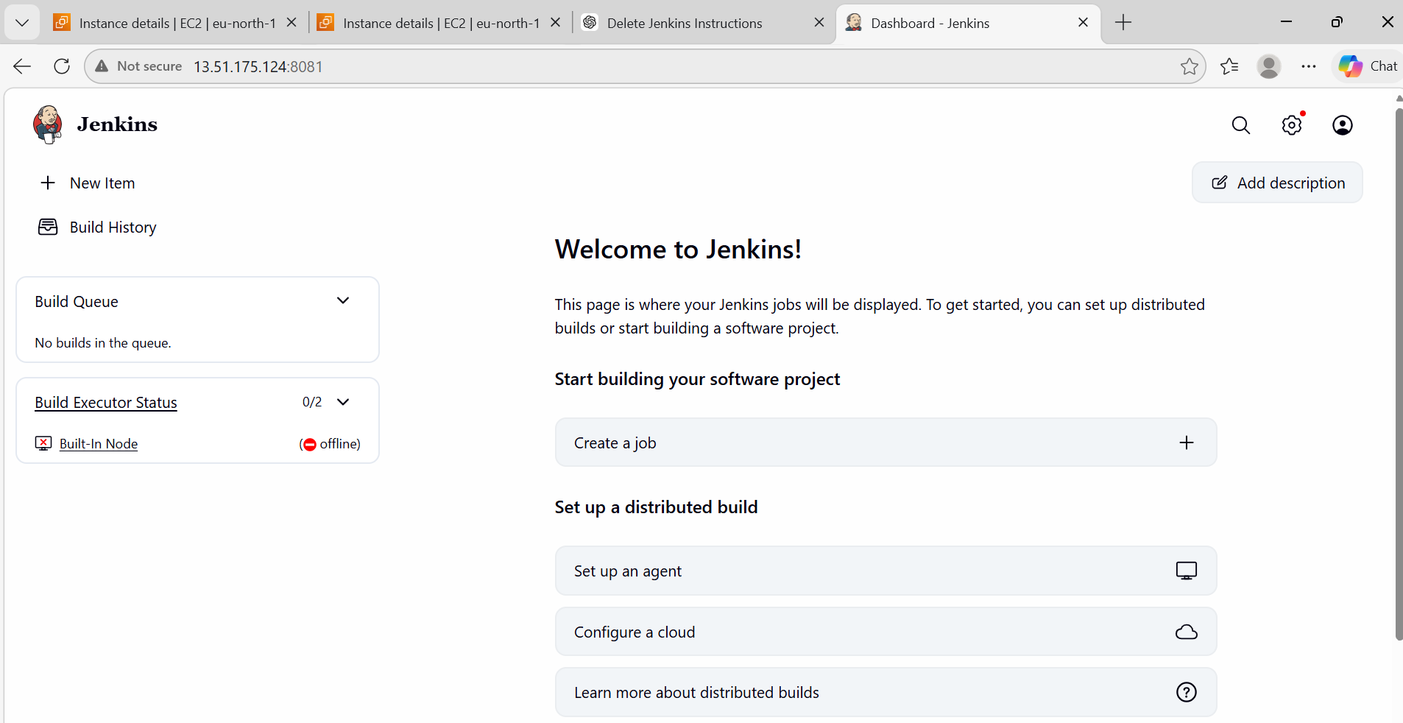
- Secure Jenkins server
Create Admin User
Fill:
- Username
- Password

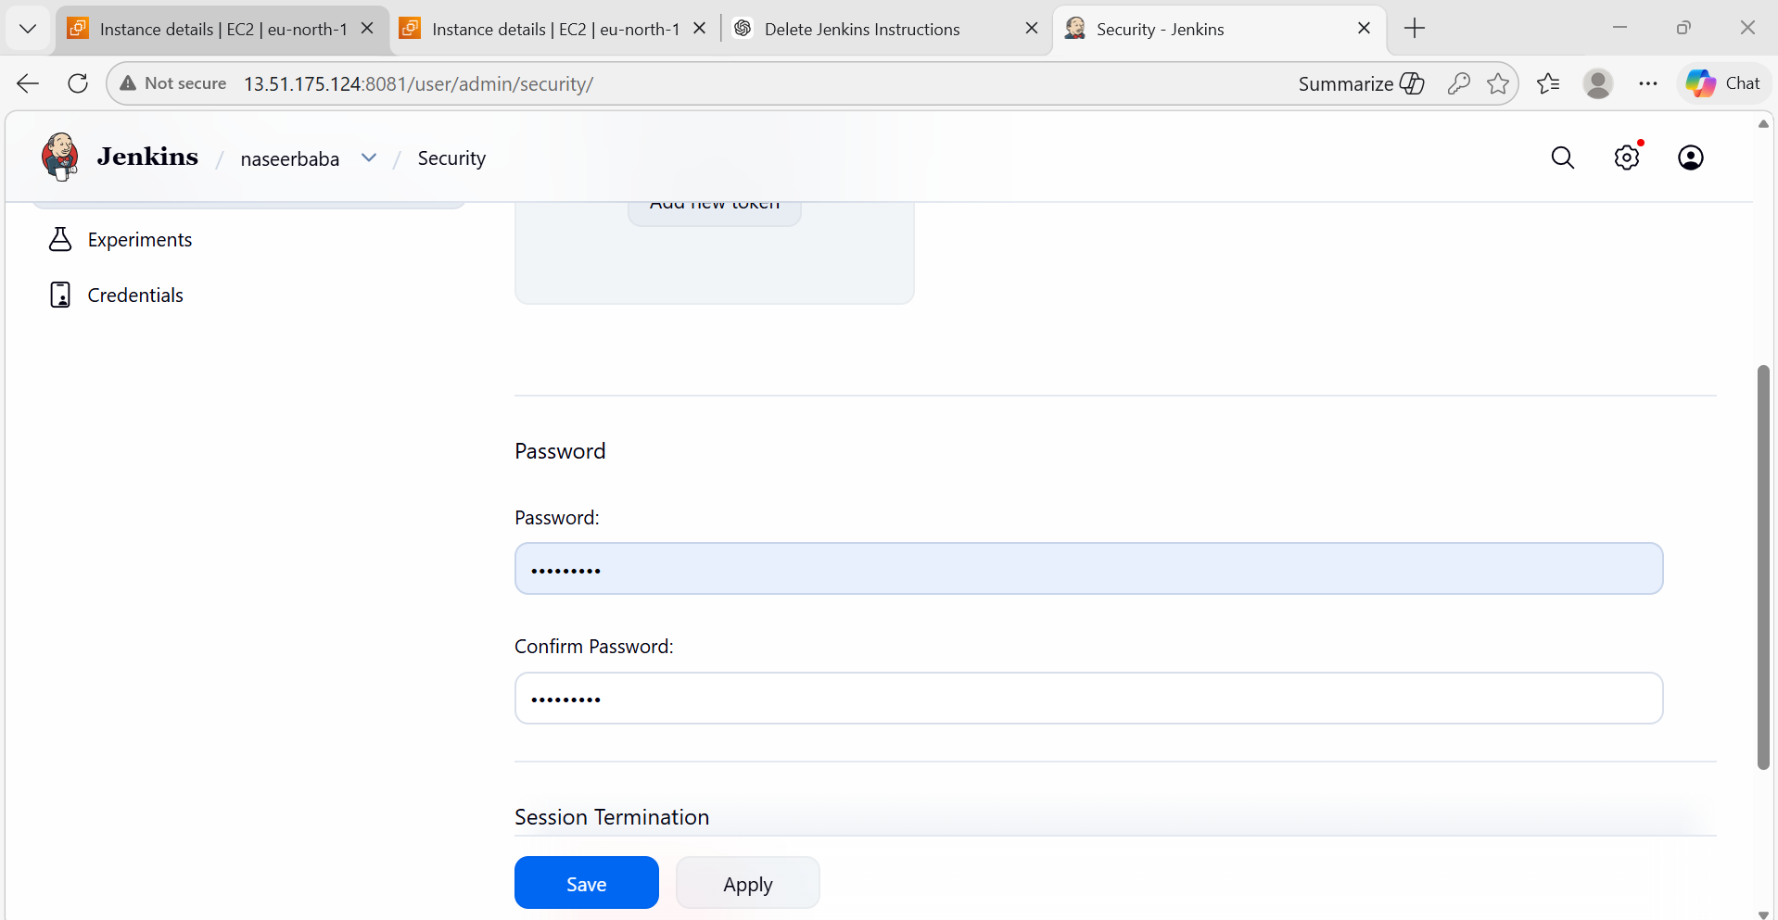
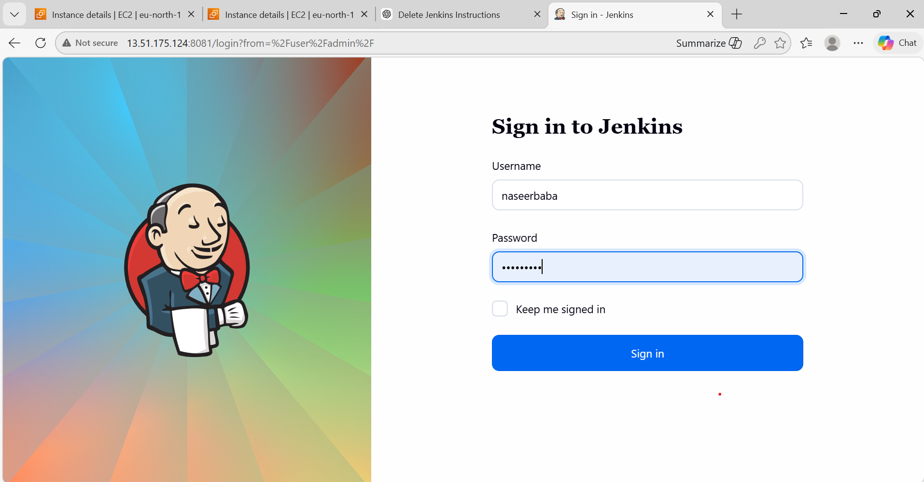
Go:
Manage Jenkins → Manage Plugins → Available
Search:
Role-based Authorization Strategy
✔ Tick it → Click: Install without restart
Open Security Settings
Go: Manage Jenkins → Configure Global Security
Enable Security Options
✔ Authentication
Select: Jenkins’ own user database
✔ Authorization (MAIN STEP )
Scroll to Authorization section
Select: Role-Based Strategy

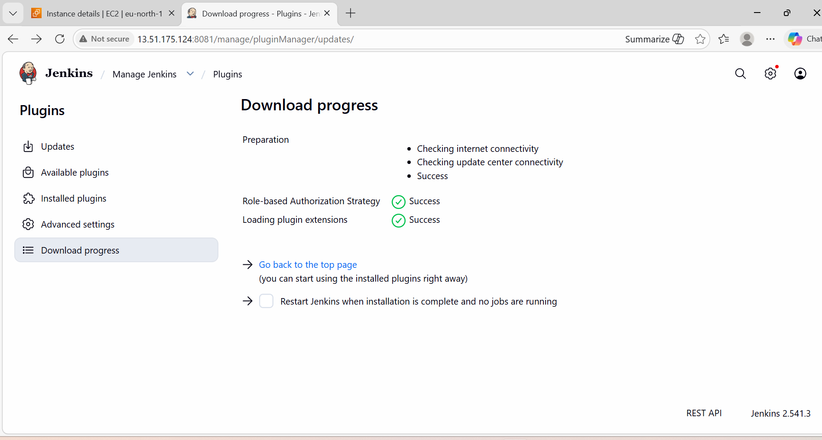

- Create users called DevOps, Testing in Jenkins with Limited access.
Create Users
Manage Jenkins → Manage Users → Create User
Create 2 users named
devops_user
testing_user
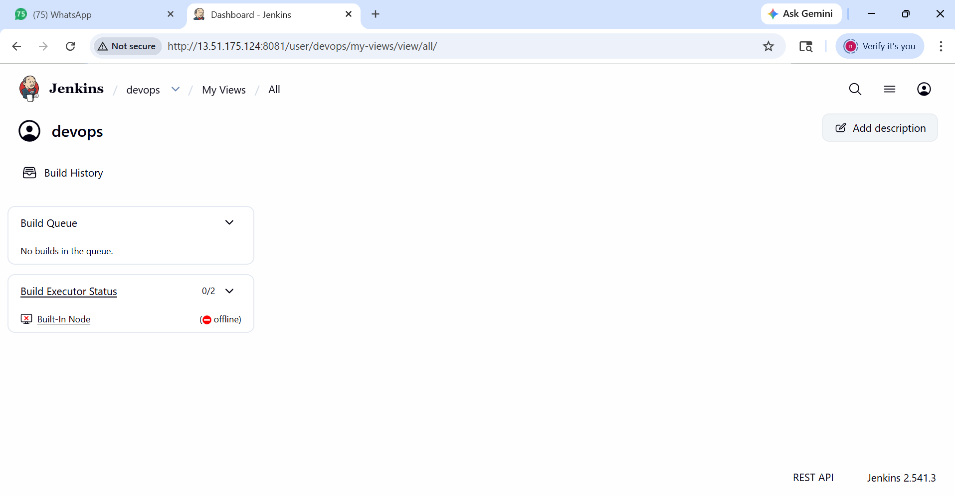

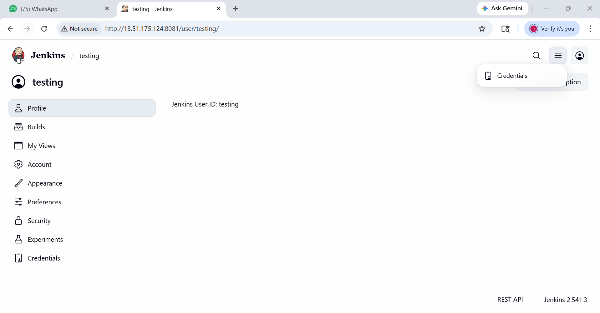
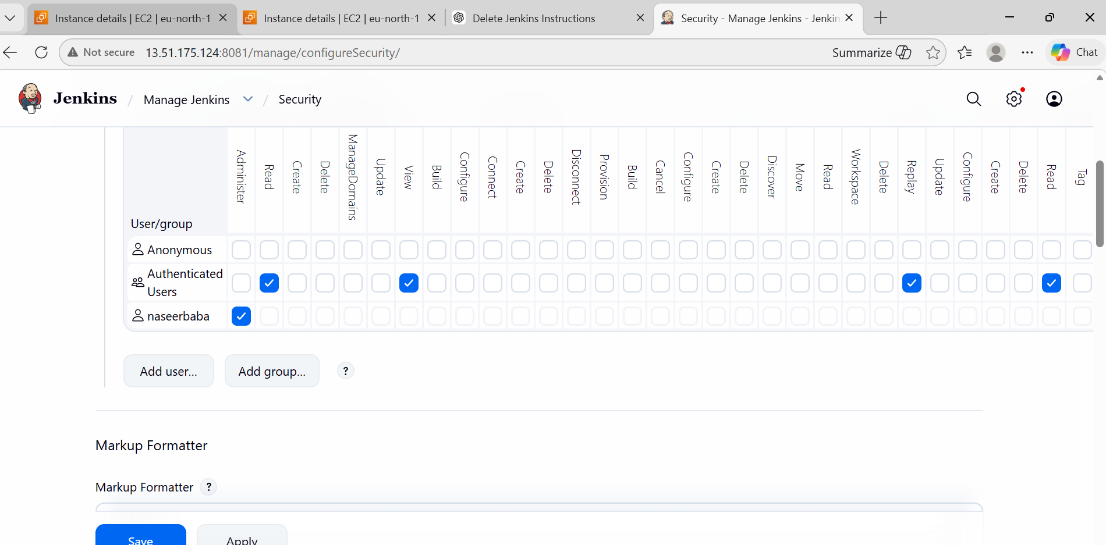

- Configure labels and restrict the jobs to execute based on label only.
Add Label to Node
Steps:
Go to Manage Jenkins → Nodes
Click on: Built-in Node (or your agent)
Click: Configure
Find: Labels
Add: jen-server
Click: Save
What just happened?
You told Jenkins: "This node is a jen server
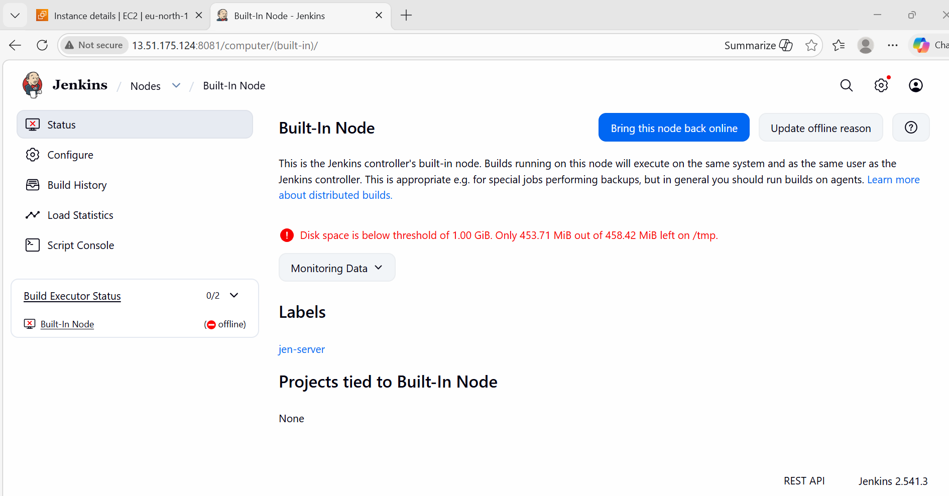
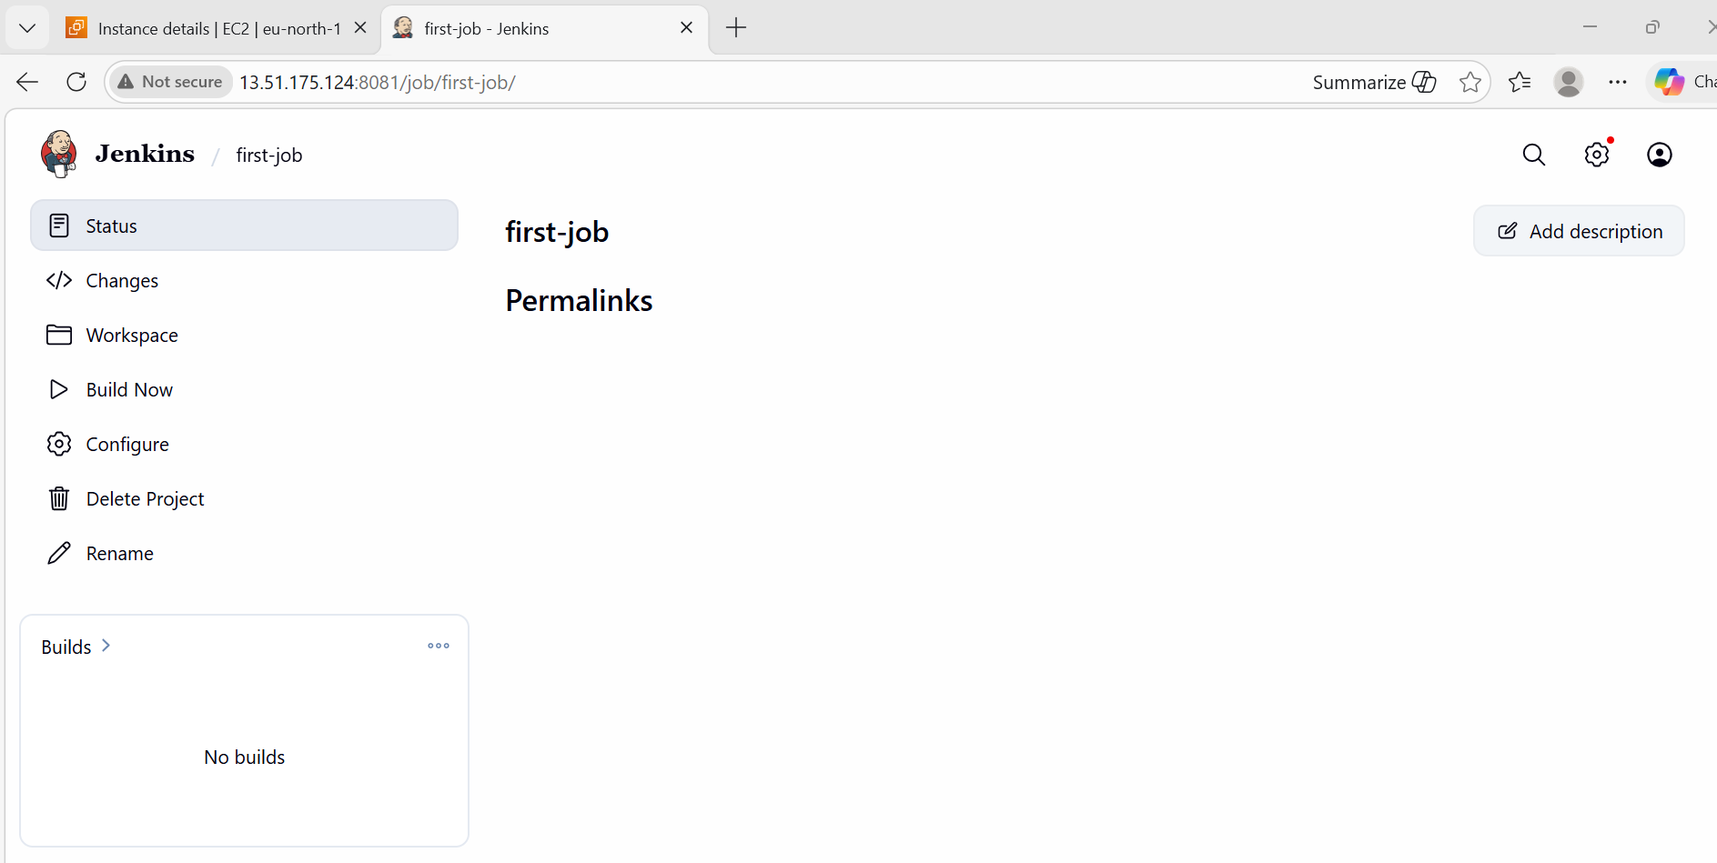

- Create Three sample jobs using the below URL.
create job
New Item → Freestyle → build-job
Git Repo: https://github.com/betawins/Techie_horizon_Login_app.git
Build Step: echo "Building app..."

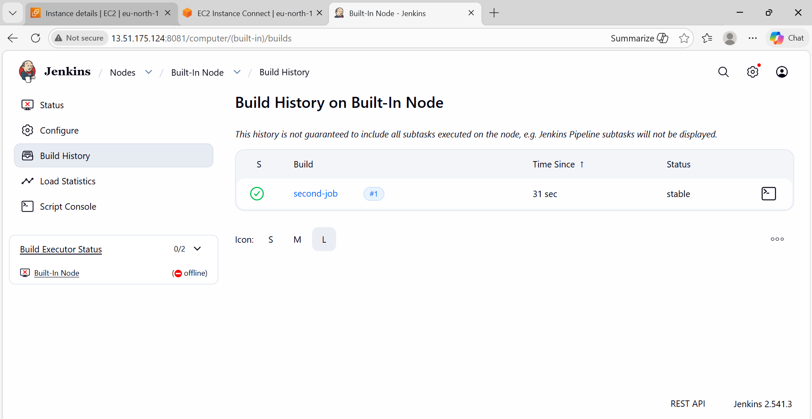
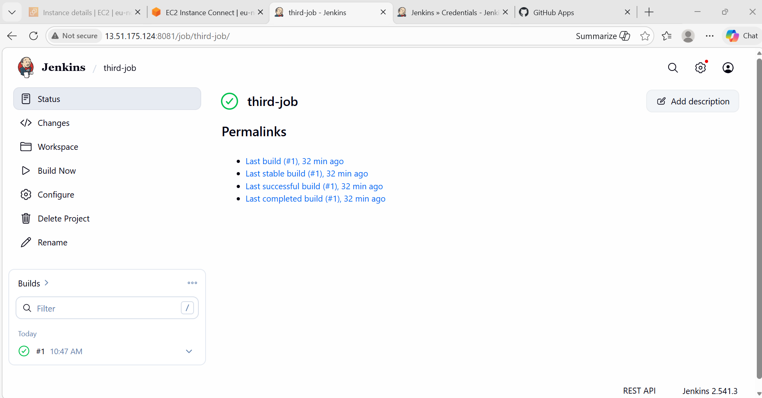
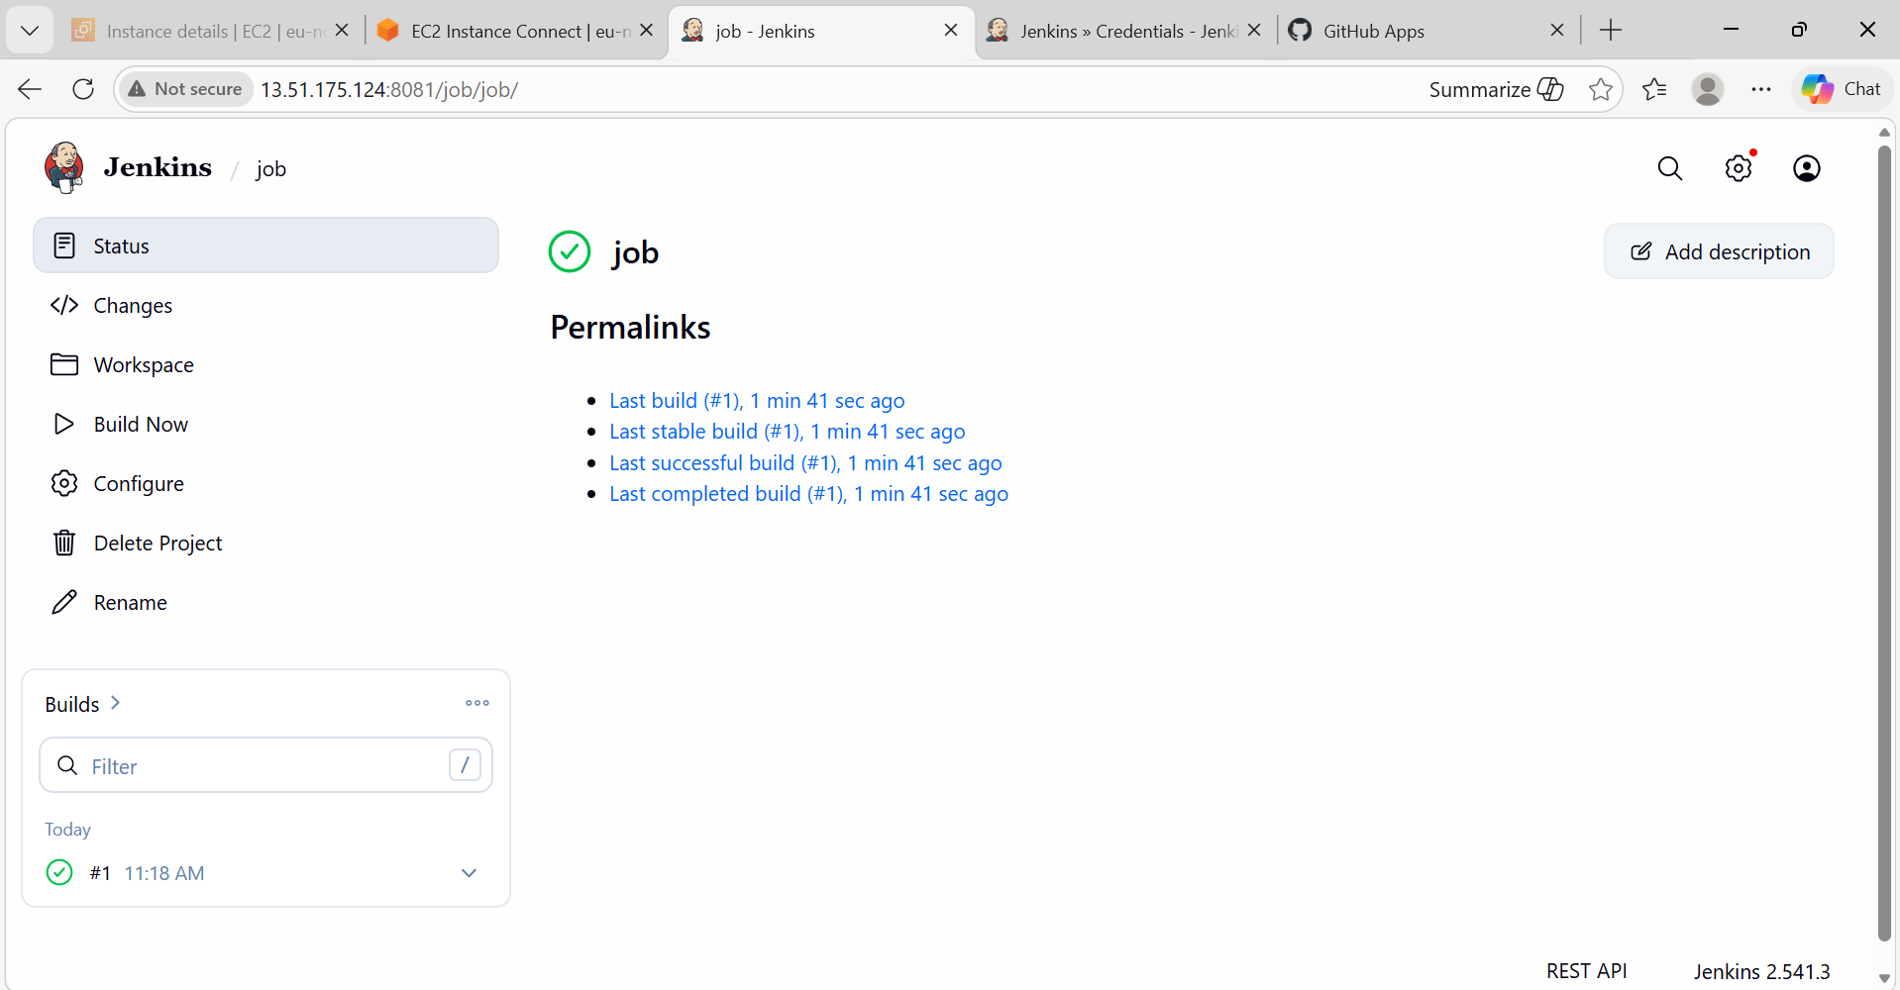
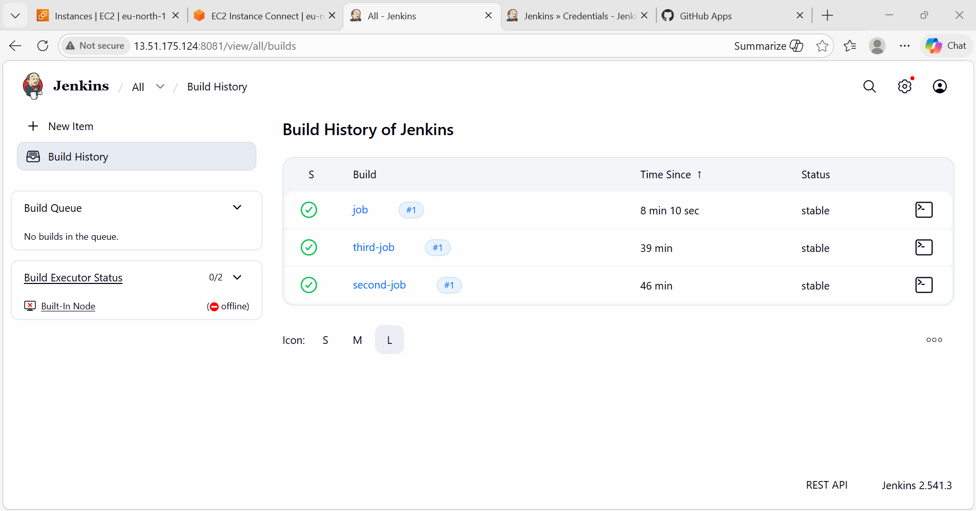
Source Code: https://github.com/betawins/Techie_horizon_Login_app.git

- Create one Jenkins job using GitHub Private repository.
Generate Token in GitHub
Go to: GitHub → Settings → Developer Settings → Personal Access Token
Add Credentials in Jenkins
Manage Jenkins → Credentials → Add Credentials
Type:
Username + Token
Create Job Using Private Repo
New Item → private-job
Add: Git URL
Credentials (select token)
Screenshot:
Credentials added
Successful build

